
A 10
SET NO : 1

Sreenidhi Institute of Science & Technology
(An Autonomous Institution)
Code No: 111ME02

B. TECH. I – Year II – Semester Examinations, June/July, 2012 (Regular-FN)
ENGINEERING DRAWING - II ( ECE & CSE )

Time: 3 Hours Max. Marks : 70

Note : No additional answer sheets will be provided.

Part-A (Objective Type)
Max.Marks:20

Answer all QUESTIONS.

1. What is meant by representative fraction and Length of Scale?
2. Differentiate between the plain scale and diagonal scale.
3. What is meant by development of surfaces? What is its purpose?
4. Write the applications of development of surfaces in engineering.
5. Define isometric projection.
6. What is meant by isometric scale?
7. Define horizon line, ground line, center of vision and station point.
8. Define vanishing point.
9. Discuss about first, second, third and fourth angle projections?
10. List various commands used for generation of objects in AUTOCAD.

Part – B
Max. Marks: 50

ANSWER ANY FIVE QUESTIONS. EACH QUESTION CARRIES 10 MARKS.

1. A rectangular plot of land of area 16 square meter is represented on a map by a rectangle of 1 square centimeter. Calculate the RF of the scale of the map. Construct a plain scale to read meters from the map. The scale should be long enough to measure up to 60 m. On the scale indicate a distance of 45 m. [10m ]

2. A regular pentagonal pyramid of side of base 40 mm and altitude 75 mm has its base on HP with a side of base perpendicular to VP. The pyramid is cut by a section plane which is perpendicular to the VP and inclined at 30° to the HP. The cutting plane meets the axis of the pyramid at a point 30 mm below the vertex. Obtain the development of the remaining part of pyramid. [ 10 m ]

3. A cylinder if diameter of base 40 mm and axis 55 mm long is resting on its base on HP. It is cut by a section plane perpendicular to VP and inclined at 45⁰ to HP. The section plane is passing through the top end of an extreme generator of the cylinder. Draw the development of the surface of the cut cylinder. [10 m ]

4. A cone of base diameter 30 mm and height 40 mm rests centrally over a frustum of a hexagonal pyramid of base side 40 mm, top base side 25mm and height 60 mm. Draw the isometric view of the combined solid. [10 m ]

5. Draw the front view, top view and side view of the object whose isometric view is shown in below figure 1. [ 10 m ]
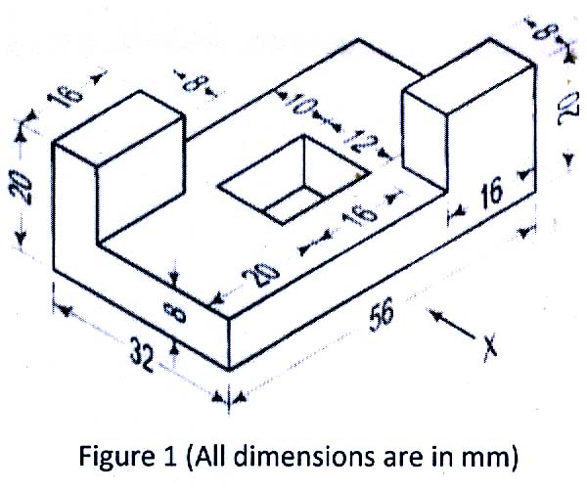
6. Draw the isometric view for the orthographic view shown in figure 2. [ 10 m ]
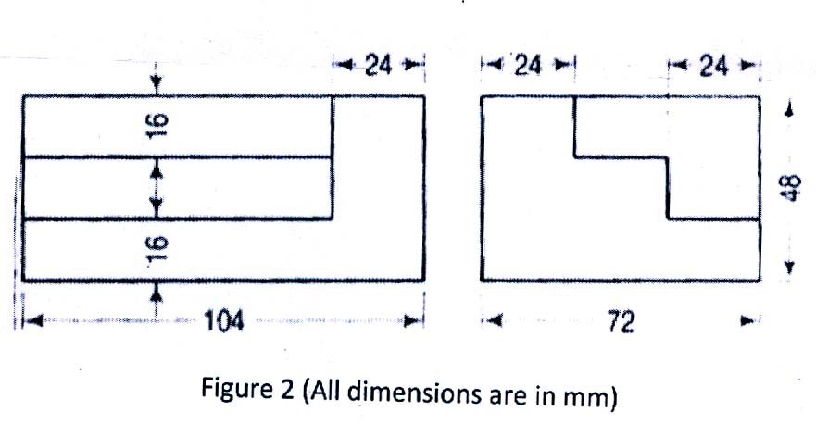
7. Draw the perspective projection of a straight line AB 60 mm long is parallel to and 10 mm above the GP and inclined at 45⁰ to PP. The end A is 20 mm behind the PP. Station point is 35mm in front of the PP and 45 mm above the GP and lies in central plane passing through the midpoint of AB. [ 10 m ]

8. Write the advantages of CAD systems in design and write about the hardware requirements for implementing CAD system. [ 10 m ]

-- 00 -- 00 --

